Cockatiel (Nymphicus hollandicus)

Pet Suitability:
Excellent pet for beginners, very good mimics.
Genus:
Nymphicus
Species:
hollandicus
Size: | Adult Weight:
29-33 cm (11-12.9 in) | 80-100g (2.8-3.5 oz)
Longevity:
20 yrs
Diet:
Mixture of small seeds: canary, millet and smaller amounts of oats, buckwheat, safflower; limited sunflower seed, millet spray; rearing food made from hard-boiled egg, green leaves and other vegetables, seeding grasses, fruits, complete pellets for cockatiels.
Enrichment:
Bathing; foot toys, destructible (non-toxic) toys, non-destructible (non-toxic plastic) toys, food-finder toys, preening toys, different texture and size hanging perch toys, push-and-pull toys (sliding up and down), vegetable tanned leather toys.

The only member of the genus Nymphicus, the Cockatiel has previously been considered a crested parrot or small cockatoo. However, more recent molecular studies have settled the debate, showing their closest relatives to be the black cockatoos of the genus Calyptorhynchus. They are hence now classified as the smallest of the Cacatuidae (cockatoo family).

Normal Color Cockatiels
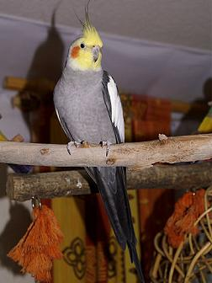

Lutino Cockatiel
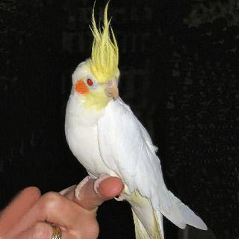

Albino Cockatiel (Visual white face Lutino)
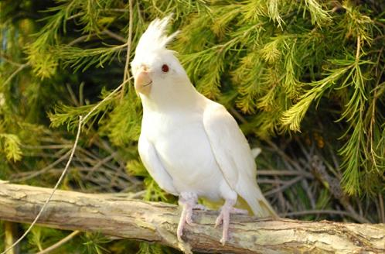

Cinnamon Cockatiel
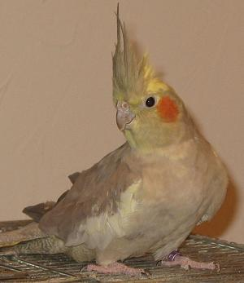

Fallow Cockatiel
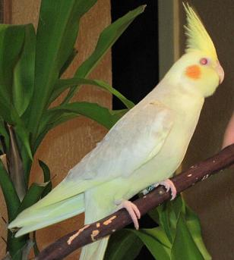

Pied Cockatiel
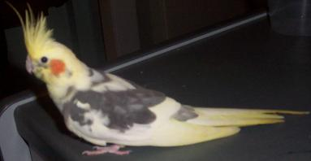

Pearl Cockatiel
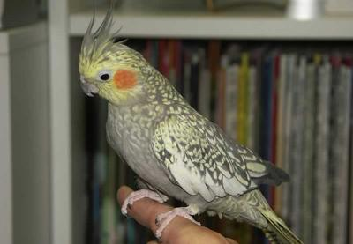

White Faced Cockatiel
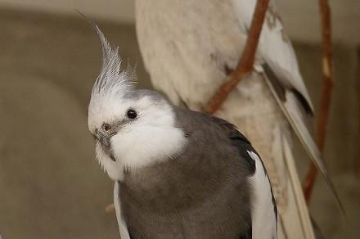

Olive Cockatiel
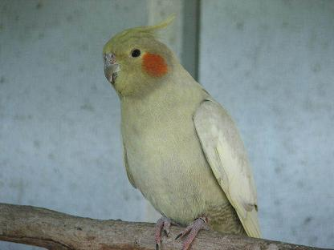

Yellow Cheek Cockatiel
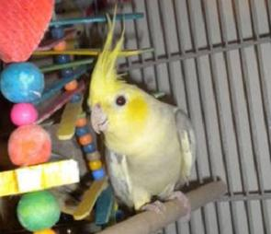

Pastel Face Cockatiel
