Green-cheeked Conure (Pyrrhura molinae)

Also Known As: Yellow-sided Conure, Cinnamon Conure, Pineapple Conure

Pet Suitability:
Medium voice; may learn to mimic. Handraised babies have sweet disposition, but may go through a 'nippy' period. Lively and playful.
Genus:
Pyrrhura
Species:
molinae
Size: | Adult Weight:
26cm (10.1 in) | 60-80g (2.1-2.8 oz)
Longevity:
10+yrs
Diet:
Fruits such as: apple, pear, banana, cactus fruits, pomegranate, forming about 30 percent of diet; vegetables such as: carrot, celery, green beans and peas in the pod; fresh corn; green leaves such as: Swiss chard, lettuce, sowthistle, dandelion, chickweed; spray millet; small seed mix such as: canary, millet and smaller amounts of oats, buckwheat and safflower; soaked and sprouted sunflower seed; cooked beans and pulses and boiled maize; limited cubed hard cheese; complete pellet.
Enrichment:
Are avid bathers; provide fresh water daily. Are very active so provide foraging toys, swings, ladders, bird-safe (unsprayed) wood chew toys, vegetable tanned leather toys.

Color Mutations:

Normal Green Cheek Conure Yellow Side Green Cheek Conure

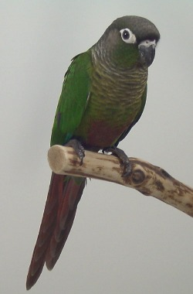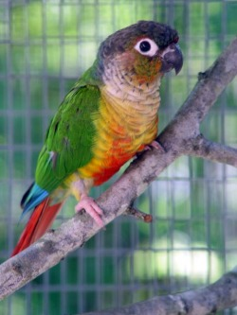

Pineapple Green-cheeked Conure  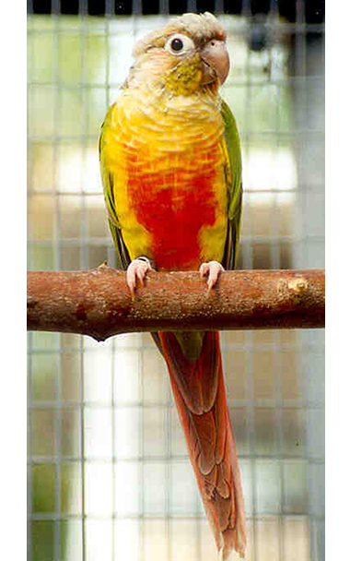 | Cinnamon Mutation Green-cheeked Conure  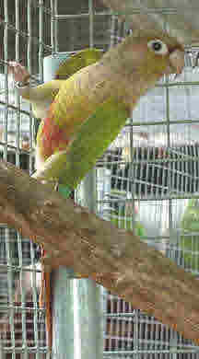

Turquoise Green-cheeked Conure
