Pacific Parrotlet (Forpus coelestis)

Also Known As: Celestial Parrotlet, Lesson's Parrotlet Not: Spectacled Parrotlet (Forpus conspicillatus) or lucida Pacific parrotlet (Forpus coelestis lucida)
Pet Suitability:
Feisty and playful. The second smallest true parrot in the world, with a macaw sized personality. Males may become possessive or aggressive. Has tendency to become obese if in small cage. If kept with a mate ensure cage is large enough, as males will become aggressive to females if in a small cage.
Genus:
Forpus
Species:
coelestis
Size: | Adult Weight:
12.5cm (4.8 in) | 33g (1.1 oz)
Longevity:
Up to 25yrs.
Diet:
Small seed mix such as: canary, millet and smaller amounts of oats, buckwheat, safflower and hemp; limited sunflower seed; spray millet; green leaves such as: Swiss chard, lettuce, dandelion, chickweed, sowthistle; seeding grasses; rearing food made from: hard-boiled egg, wholegrain bread, low-fat cheese and carrot, all ground to crumbly consistency; apple and other fruits if taken; complete pellets.
Enrichment:
Swings and ropes; puzzle and foraging toys; bird-safe wooden chew toys. Also like to bathe.

Interaction with other Birds
Caution must be advised regarding interaction with other birds. Very often a Parrotlet, especially a Pacific, will attack a much larger bird with no regard for their own small size. Particularly when they become mature enough to breed, they can become especially hostile toward other birds. Do not allow your Parrotlet to be unsupervised around other birds.

The Lost Lucida
There is one subspecies, the lucida Pacific parrotlet (Forpus coelestis lucida) where the females have blue rumps and eye streaks and, sometimes, wings although it is not as dark blue as the males. Males of this subspecies have silver gray backs and wings as well an eye streak that completely encircles the back of the head. This subspecies is found in Columbia.

Blue American White
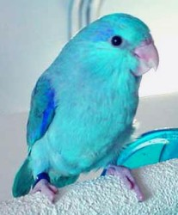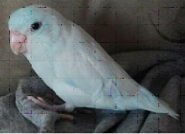
Green, Yellow, and Blue
