Scarlet-chested Parakeet

Also Known As: Scarlet-chested Grass-Parakeet, Scarlet-breasted Parrot or Grass-Parakeet, Splendid Parrot or Grass-Parakeet
Pet Suitability:
Quiet; has melodic, pleasing voice. May be housed with smaller birds. Shy at first, then becomes accustomed to keeper. Susceptible to cold.
Longevity:
10yrs
Genus:
Neophema
Species:
splendida
Size: | Adult Weight:
20cm (7.8 in) | 36-44g (1.3-1.5 oz)
Diet:
Small seed mix such as: canary, millet, and smaller amounts of oats, buckwheat, safflower and a little hemp; limited sunflower seed; spray millet; green leaves such as: Swiss chard, lettuce, sowthistle, dandelion, chickweed; seeding grasses; rearing food made from: hard-boiled egg, wholegrain bread, low-fat cheese and carrot, all ground to crumbly consistency; fruits such as: apple, pear and banana; complete pellets.
Enrichment:
Provide bowls for bathing; if possible provide dirt or soil for the birds to scratch around in (they are ground feeders in the wild), foraging toys/bird-safe branches.
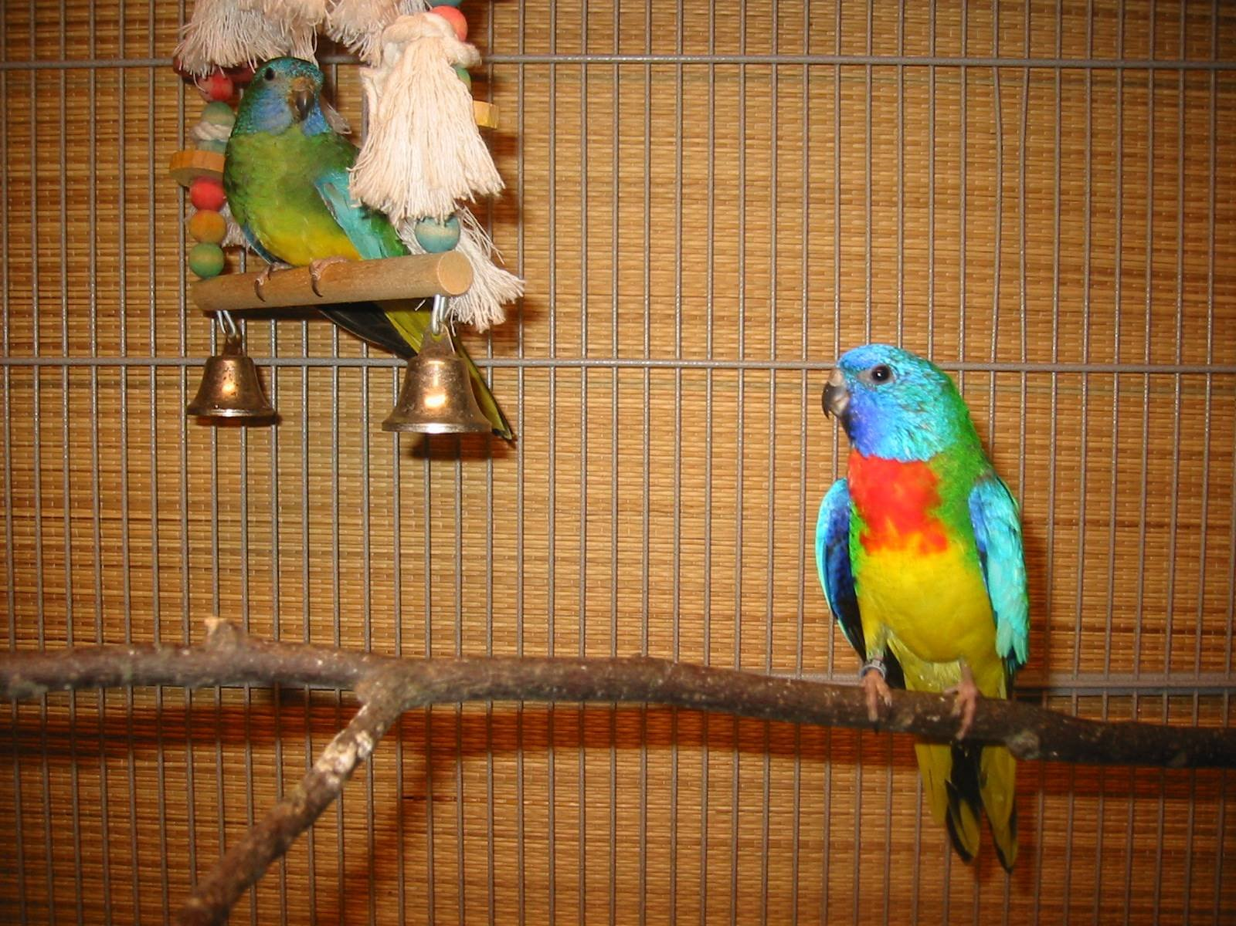
Hen on swing, male on perch. Immature birds look like hen, Males begin to get color around 6 mo. old, though do not complete their red chest until 15 to 18 months old.

